Summarizing Quantitative Data

Measuring Center in quantitative data

Statistics intro: Mean, median & mode
Statistic is about data.
Descriptive statistics : so if we have a bunch of data, and if we wanna tell something about the data without giving them all of the data, can we somehow describe it with a smaller set of numbers.
Once we build our toolkit on the descriptive statistics, then we can start to make conclusions start to make judgements, we will start to do a lot of inferential statistics.
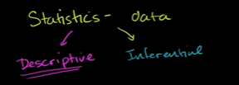

So u have plants with following height
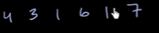
and if some1 ask “ how tall are ur plants and they only wanna hear single number”
what would u say?
So u want Single number that represent all this points.
Ans: Mean(Average)
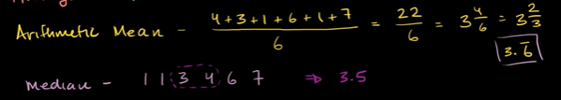
Mode is the most common or frequent number
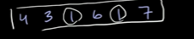
ans=1

Comparing means of distribution
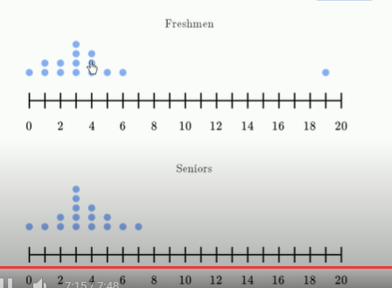

Mean is very susceptible by outliers.

Means and median of different distributions
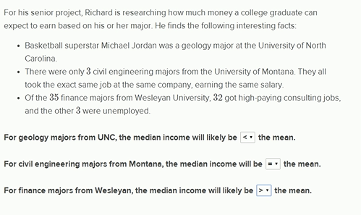

Impact on median and mean: removing an outlier
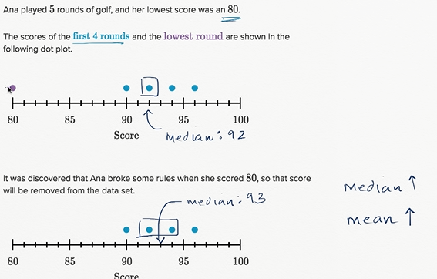
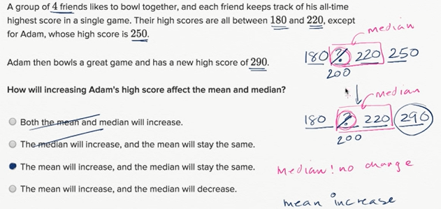

Missing value given the mean
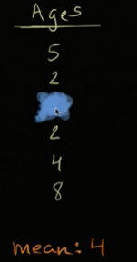

Interquartile range

Interquartile range
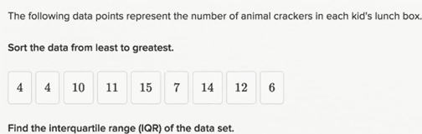

Interquartile range is all about figuring out the difference between middle of first half and middle of second half.
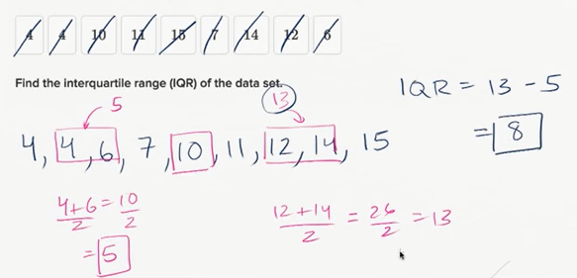

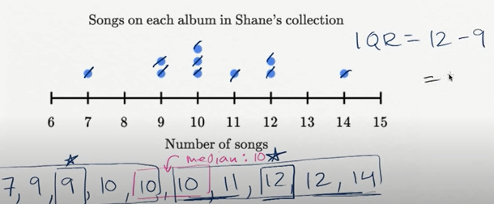

Variation and standard deviation of population

Measures of spread: range, variance & standard deviation
You wanna use samples to estimate something for the population
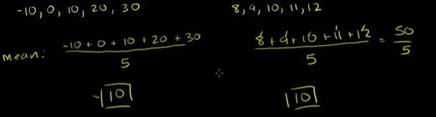
Both the population data have the same population mean.
In first population, the datapoints are more dispersed.
Different ways we can measure dispersion, or how far are we from the average/centre.
Range: Largest-No minus Smallest number
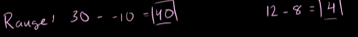

So, for the example only- Range is good measure of dispersion.
Range is not always good
Variance = (standard-deviation)^2
It is calculated,
take every element from the dataset subtract it from the mean, take average of those squares.
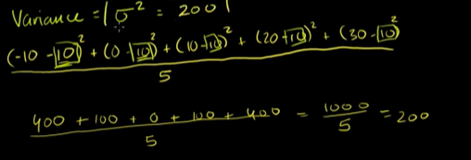

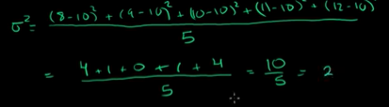

since we get metrics for meter square.
People use standard deviation which is only meter
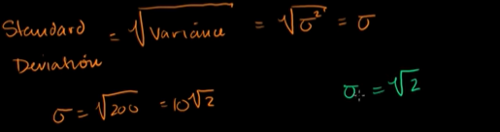

So, the second dataset has 1/10th the standard deviation compared to first 1.

Variance of population
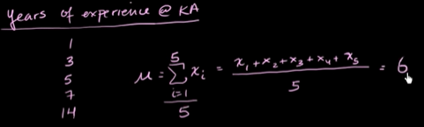
Mu is used for population mean

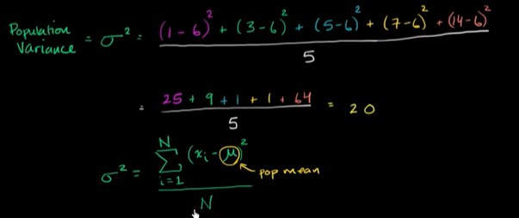

Population standard deviation
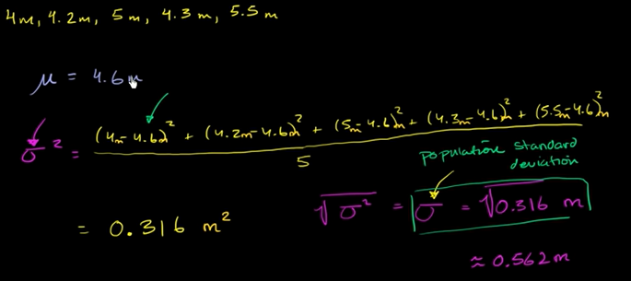
Mean and standard deviation versus median and IQR
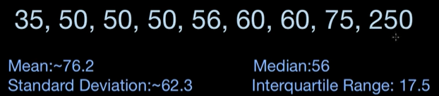
Mean is very susceptible to outliers and get skewed.
Median is not.
Since mean is not good, standard deviation is based on the mean.
Interquartile range works
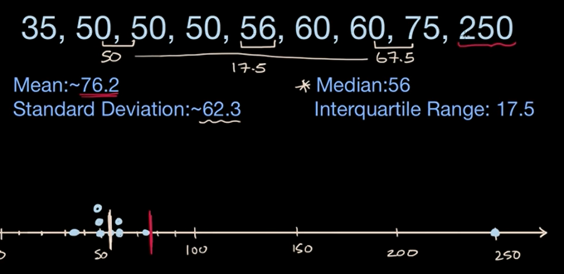
Mean and standard deviation are not bad, if you have roughly symmetric distribution. Or you don’t have any significant outlier that can skewed the dataset.

But if u have some handful of datapoints that can skewed the Central tendency, Median and IQR are good measure for spread.
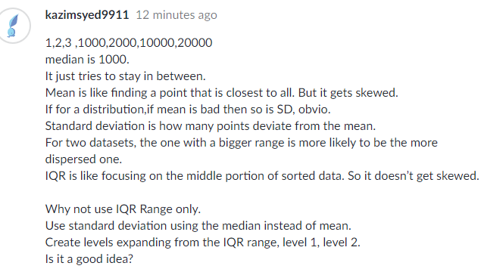

Ads talking about salary using average is misleading.
Home prices uses median, maybe there is castle in a block.

Statistics:Alternate Variance Formulas
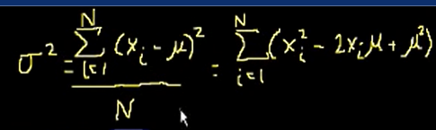
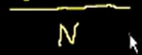

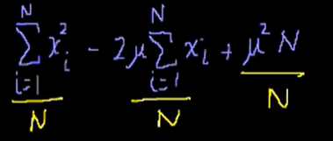

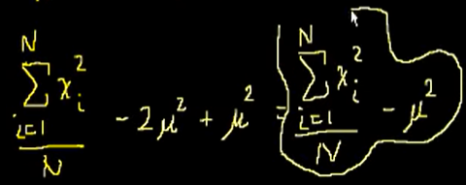

It is called raw score method.

Sample variance
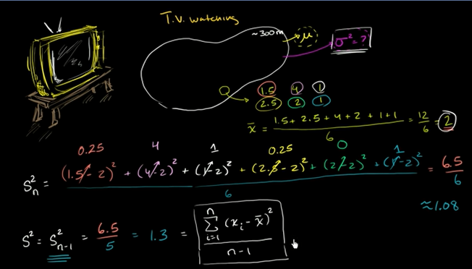
Above, Small n Is for sample , Big N is for all datapoints or population.

Sample Standard deviation and bias
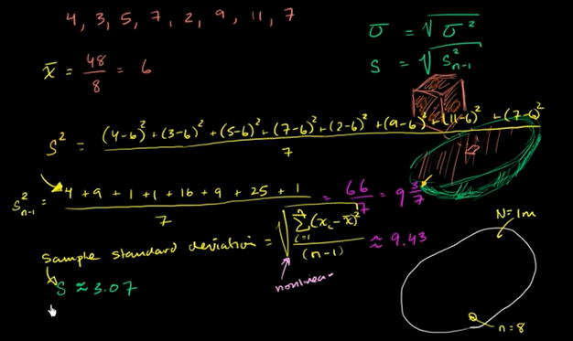

Here we divide by n-1 instead of n to get unbiased variance.
Since Square root function is non-linear, it turns out S.D is not true unbaised standard deviation

We may think just like for variance we use n-1 which works for any distribution.
We wanna play the same trick, but for standard deviation its dependent on the distribution.
So sample standard deviation gives u a biased result when you using this to estimate the population S.D
Read the comments on KA_link

More on standard deviation

Why we divide by n-1 in variance
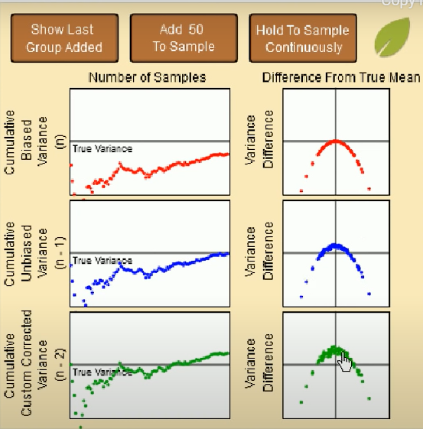

Above when hold to add samples continiously, we are adding samples and their variances is calculated. Mean of the variances is plotted. We see n-1 leads to true variance. While n and n-2 , does under and over estimate respectively.
So the mean of all my sample variance truly converge to my true variance.
Each plot is one of our sample
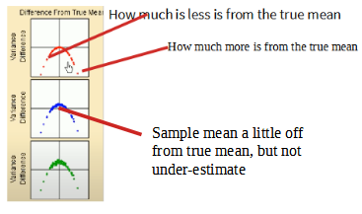
In the vertical axis, we calculate the mean calc with the sample mean vs the mean calc using the population mean.
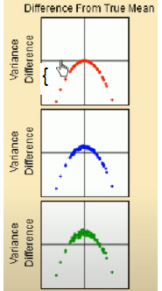
So, here the vertical difference tells the mean calcuted from the sample and if we know the population mean.
Here, when we use sample mean and “n”, we are getting a underestimate,
Whereas when using n-1, we are not always underestimating, we also get a bit overestimate.
Closest.
Its overestimate.

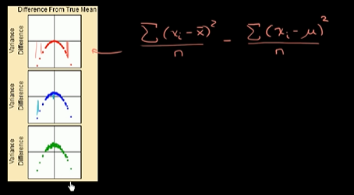

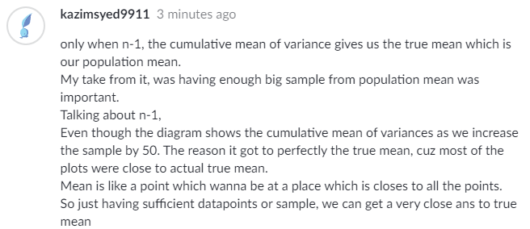

Simulation showing bias in sample variance
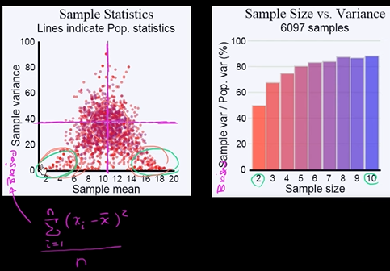

Red color represent biased result, which is likely in unsufficient sample.
Voilet color represent unbiased result which is likely in sufficient sample.
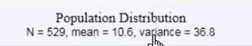

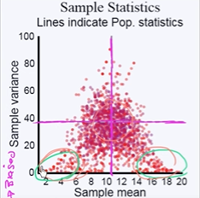
2,4,6,8,10 are Mean.
Dark Red -light red to light-dark voilet are the data points of 2-10.
10.6 and 36.8 is the Population Mean.
We see at the green circle drawn by sal, there are more red points, indicating inadequate sample size. Resulting a mean which is very not accurate and thus also variance.
He has drawn the points of the sample size and use color to which sample size it belongs. So we can tell, red points has underestimate most, both the Mean and sample variance.

To get unbiased estimate
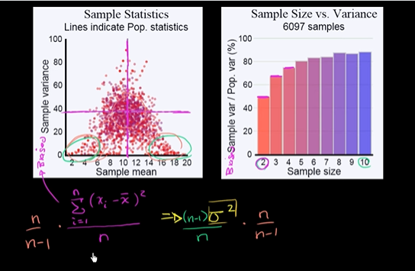

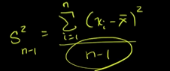

Simulation providing evidence that (n-1) give us unbiased estimate
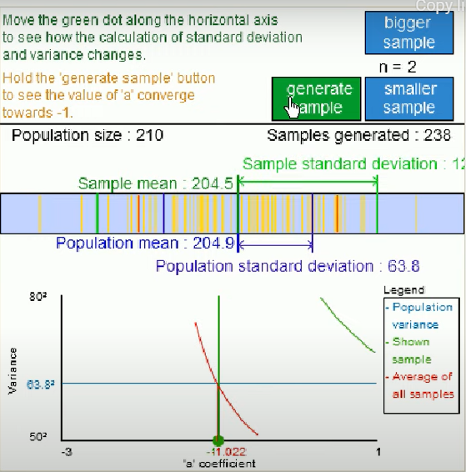

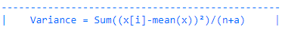

As we get more samples and Cumulative of Mean of samples we -1 as a used to get the best estimate for variance.

Review and intuition why we divide by n-1 for the unbiased sample variance
Variance is how much the datapoint varies from the mean.
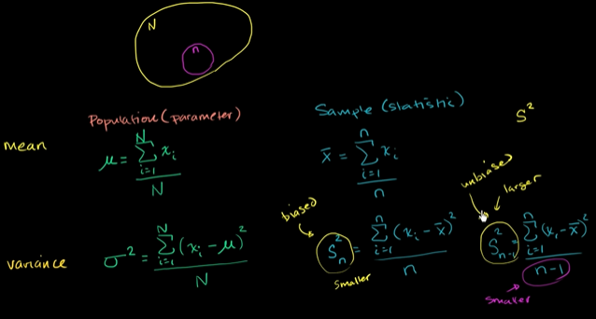
Below, we have taken 3 points for our sample, these 3 points are outlier such that average lies close to population mean
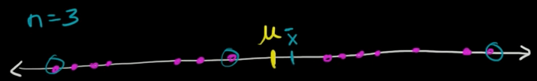

But what about when
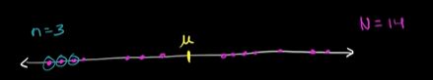

Now its really off.
Your population mean could be outside of the sample, thats the case above.
So instead of n we divide by n-1, so we get slightly larger sample variance, which is not underestimate.

Box and whiskers plot

Creaing a box plot(odd no of datapoints)
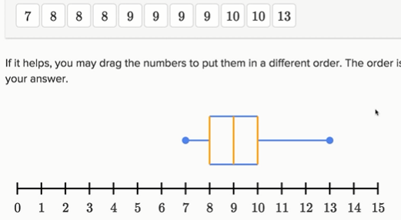

Creating a box plot(even no of datapoints)
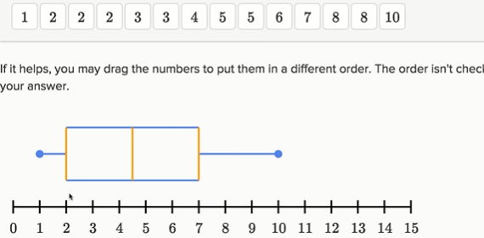

Constructing a box plot
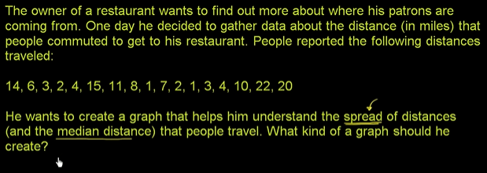
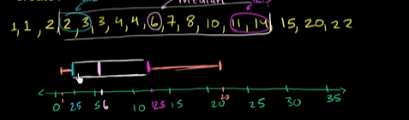

Reading box plots
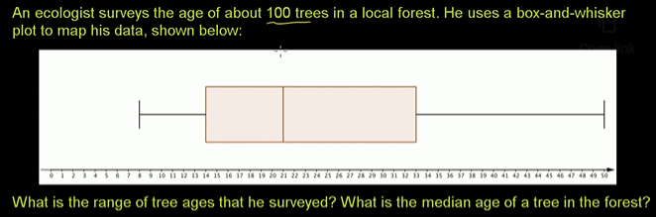
Here 14 is the first quartile.

Interpreting box plots

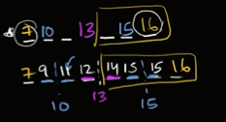
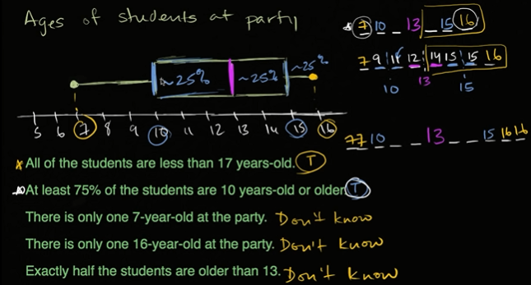
4 ans:
if its even no of points, it said older than 13.
which is greater than 13.

Judging outliers in a dataset
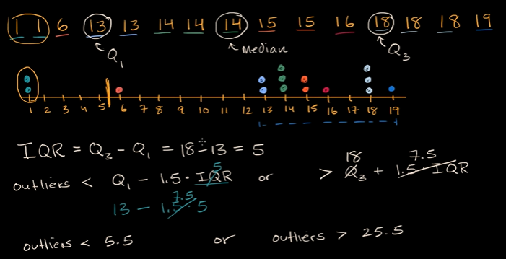
When drawing box and whisker plot
You can draw it taking in consideration the outliers or not taking in consideration the outliers.
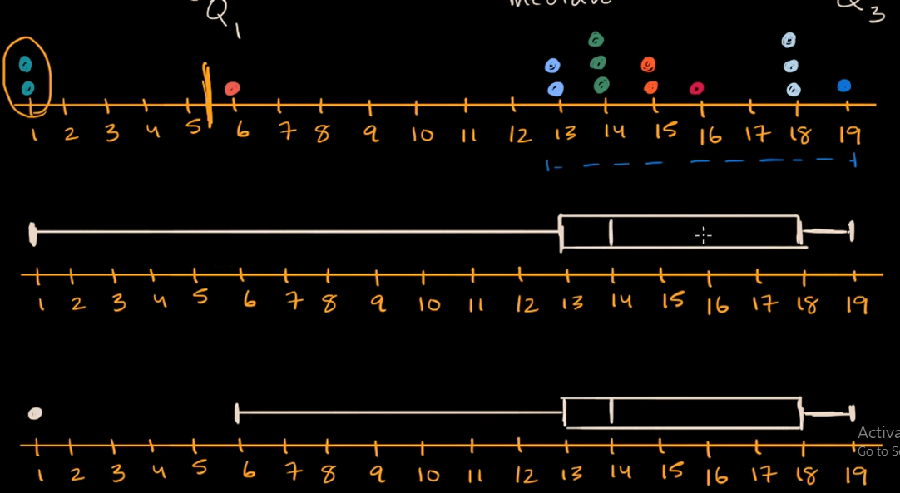

Other Measure of Spread

Range and mid-range
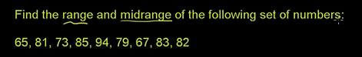

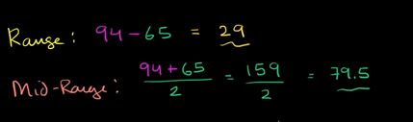

Mean Absolute deviation
How far are the datapoints from the mean
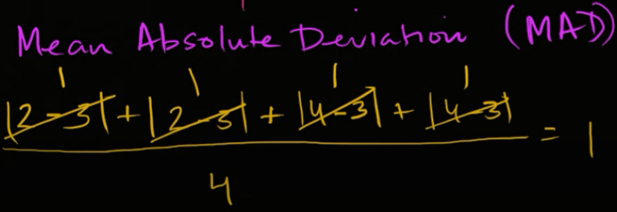

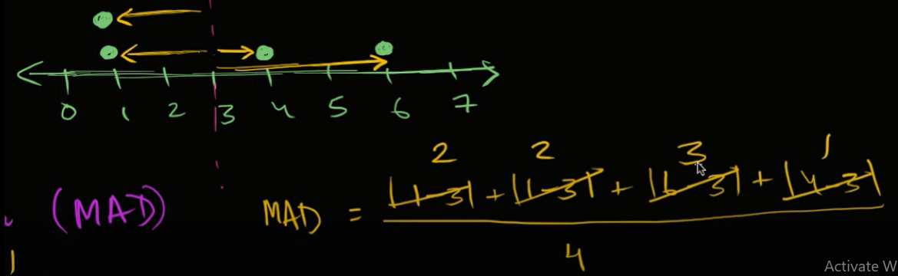

=2

Mean absolute deviation example
